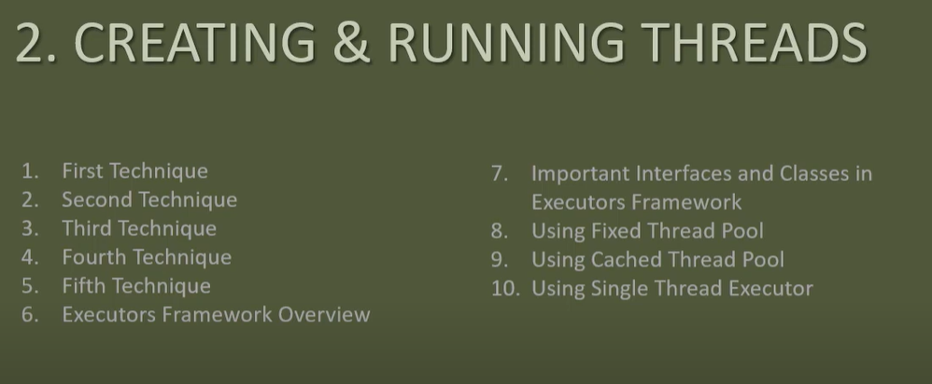

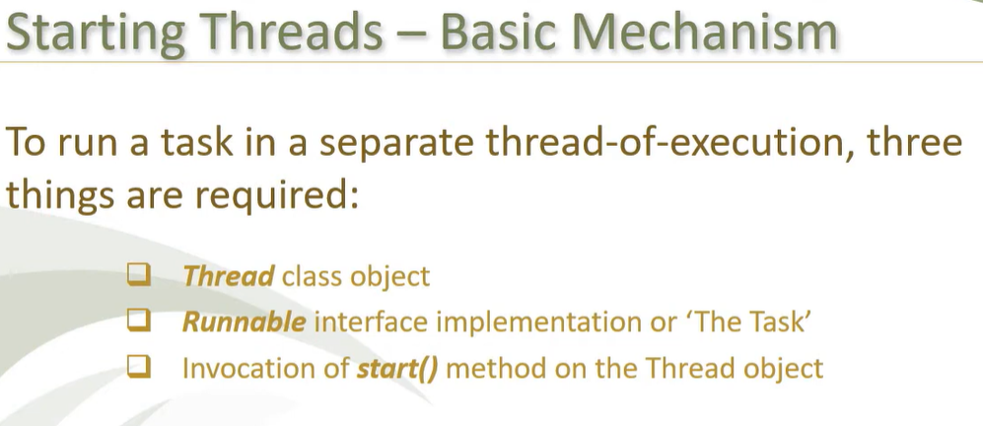

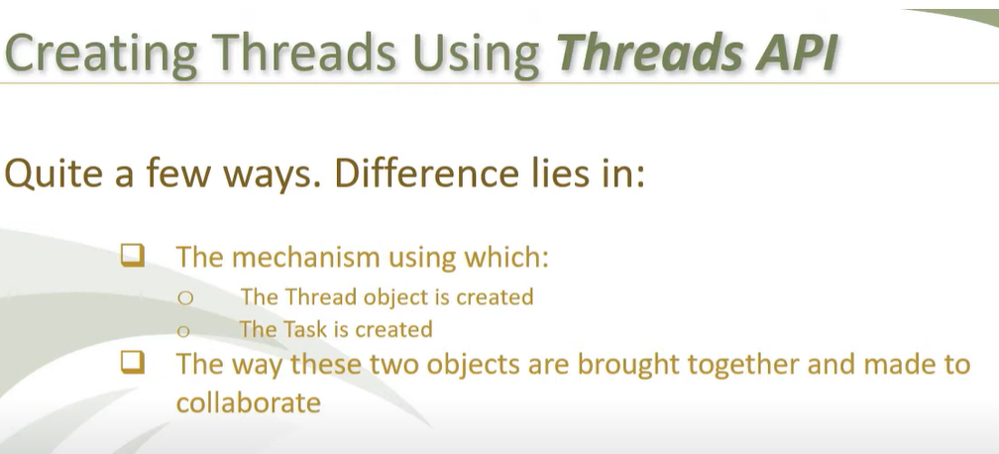

1st technique:

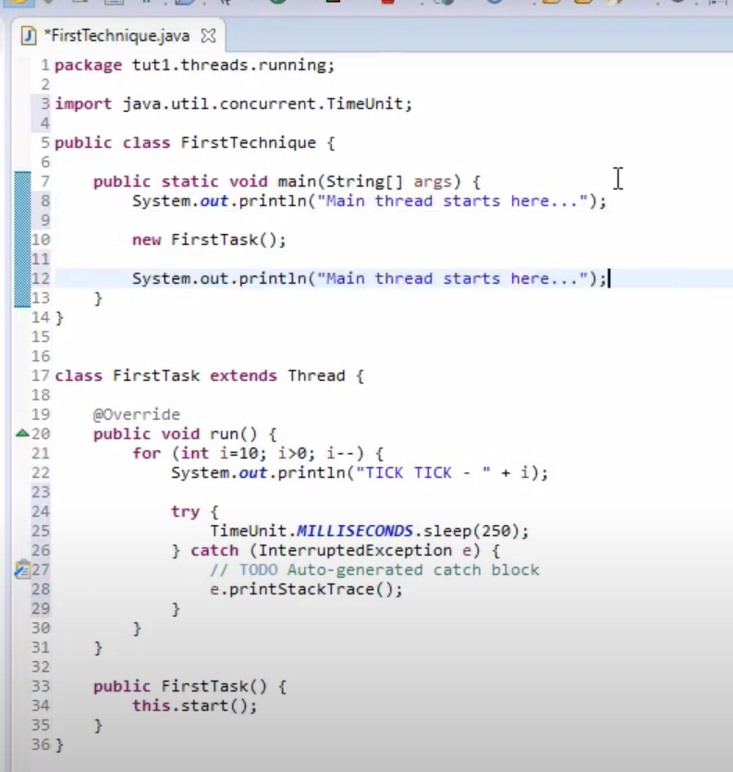

2nd Technique:

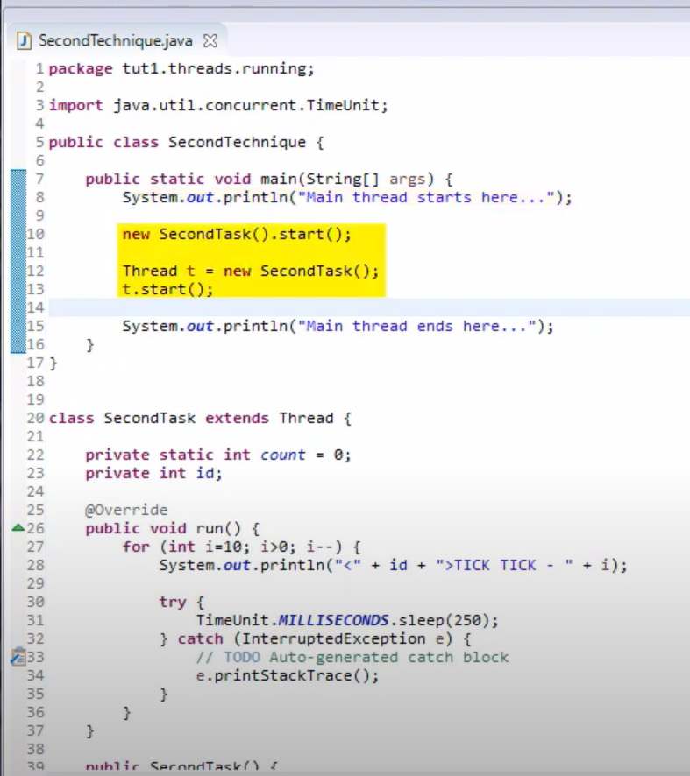

**3rd Technique: Fire and forget**

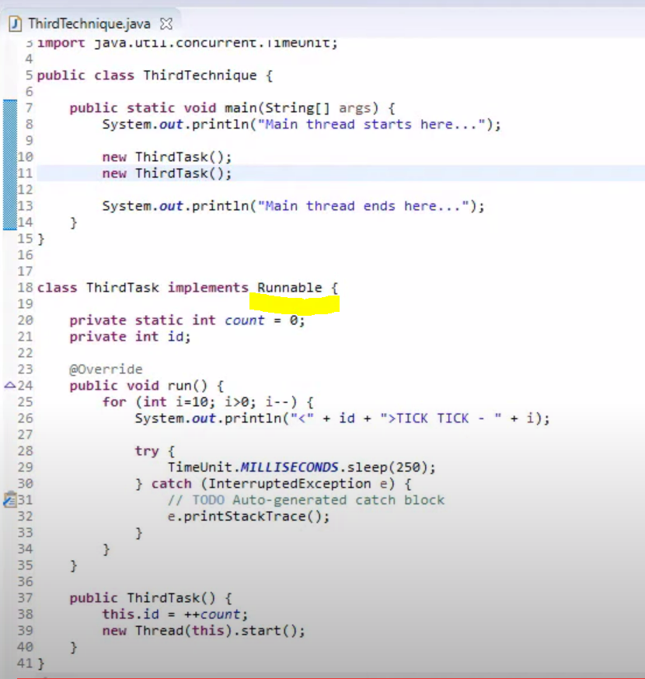

4th Technique:

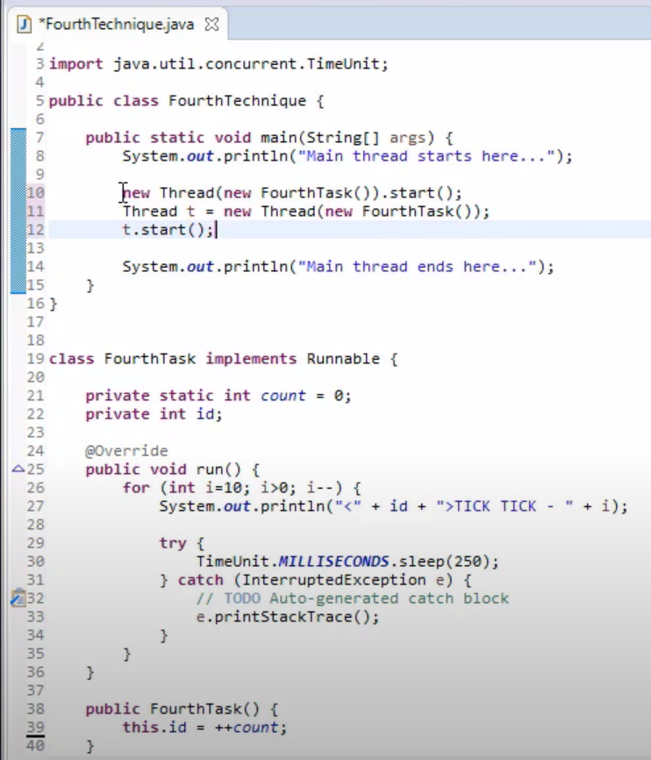

**This technique is widely used for creating and running threads due to following reasons:**

1. Task definition is entirely isolated from thread related code. Such tasks are also amenable to be executed by executors in addition to normal threads.
2. Greater control on when to create threads and when to actually run them.

5th Technique: Anonymous thread. It cannot be re-used.

You can also create thread reference to handle UI events.

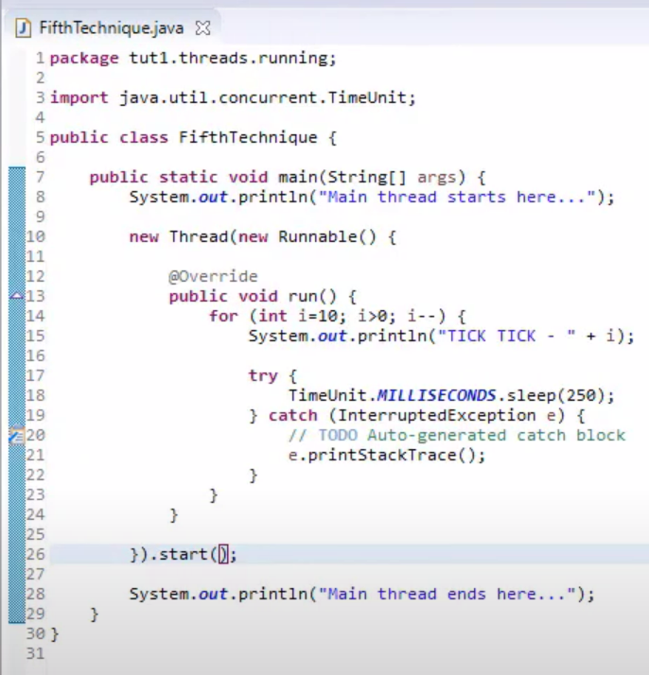

Executors API:

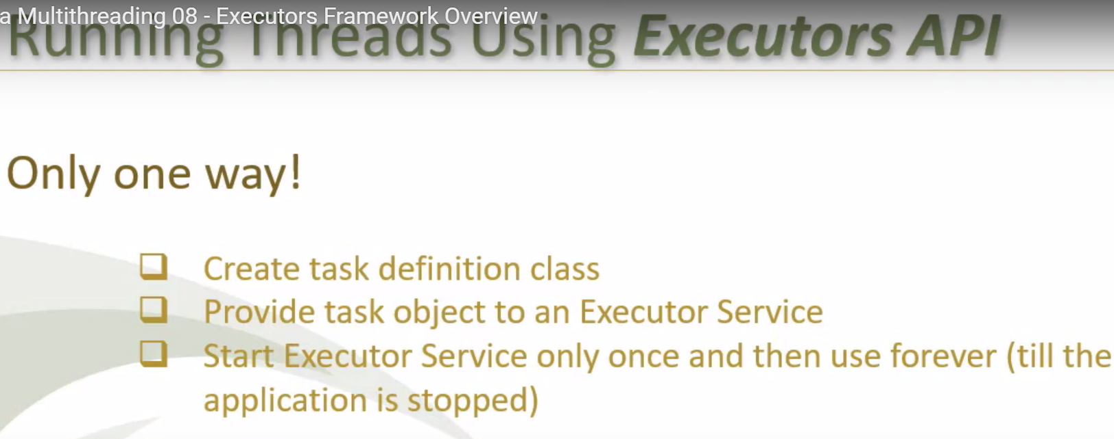

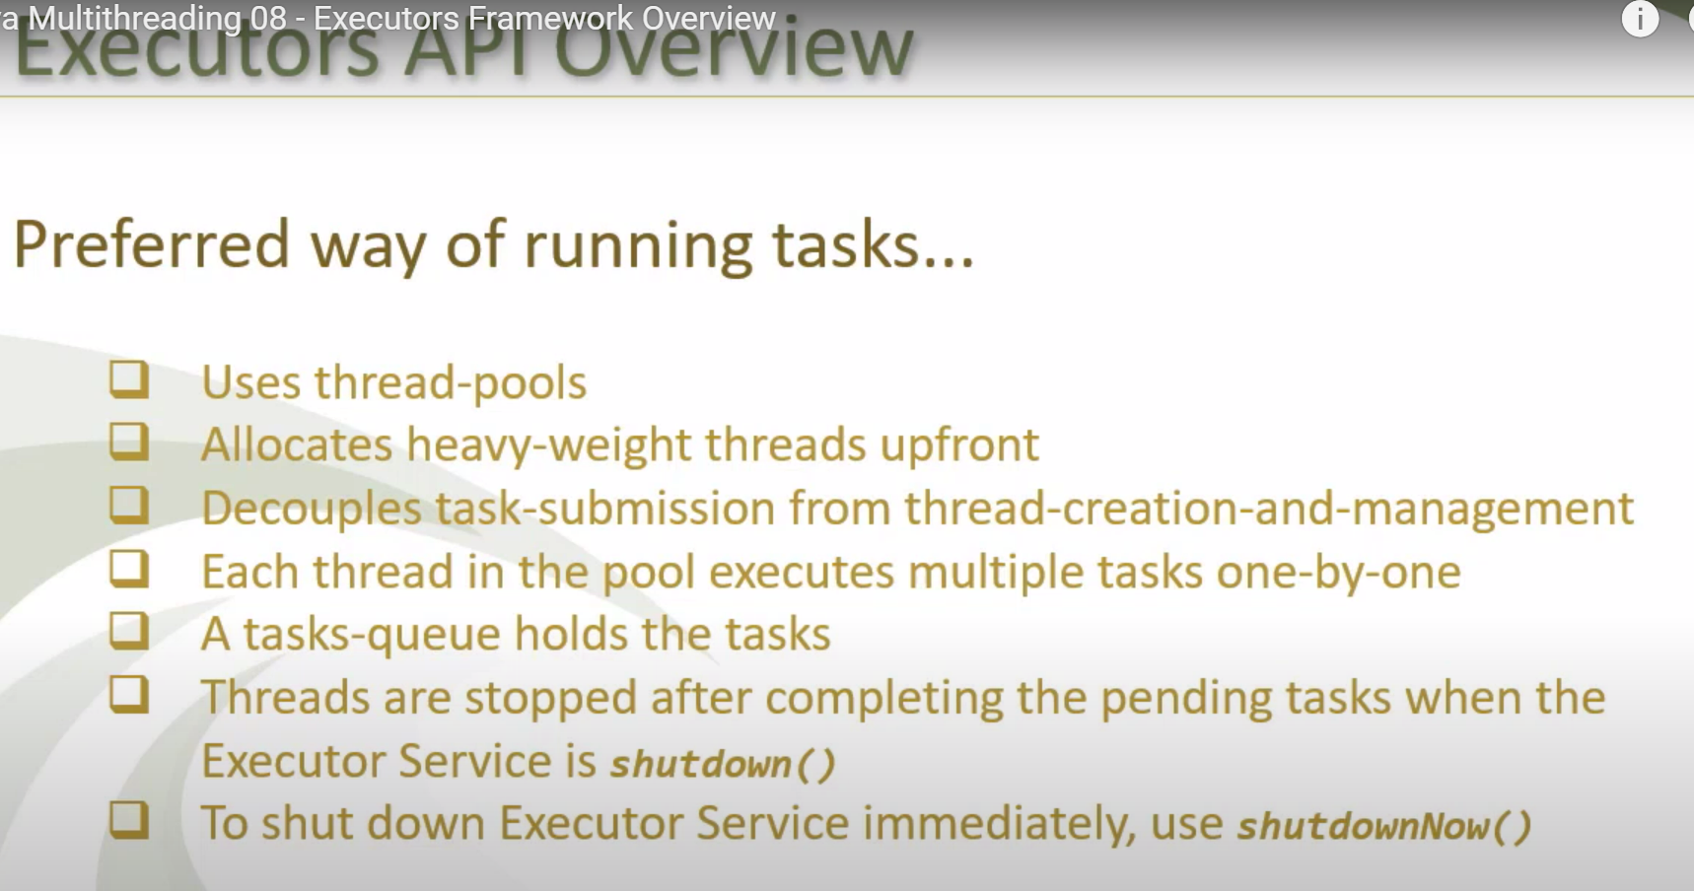

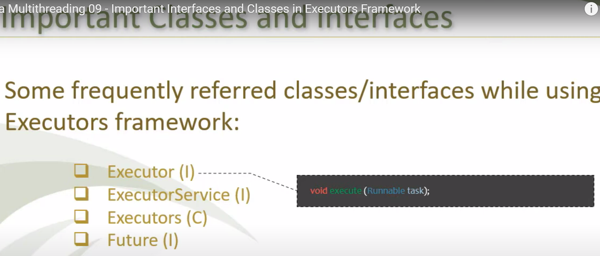

Executor interface has execute() method to start the executor.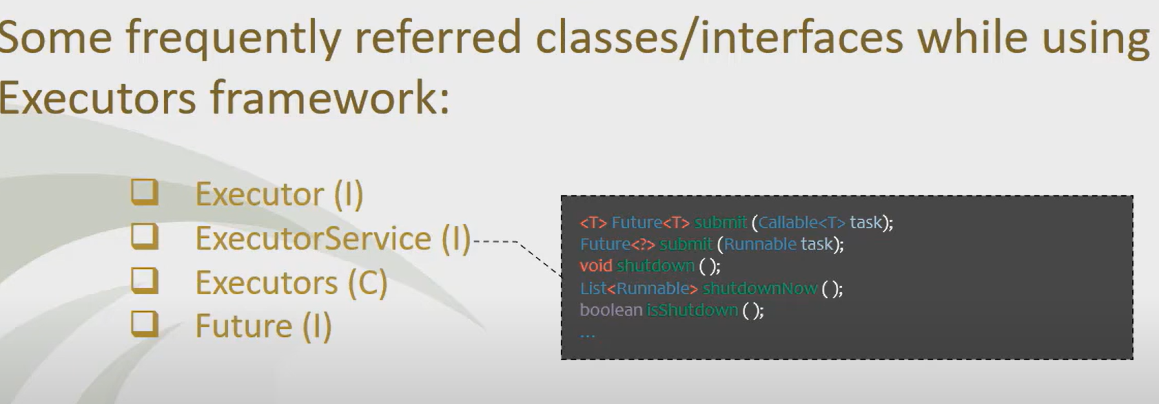

ExecutorService extends Executor interface. It provides lifecycle to executor.

Lifecycle has 3 phases:

1. Initialization – creates required no of threads and starts them too if required. Its hidden and can be customized by providing some parameters through executors class.
2. Service- It provides its services by submitting task. Submit() are service methods.
3. Destruction- It shuts down and stop accepting new tasks. Last 3 methods(shutdown) are destruction.

* When Shutdown() method is called, executor service will not accept new tasks, but tasks which are executing(existing) and pending to execute(queued tasks) will keep running. If you try to submit new task after shutdown, it will throw an **RejectedExecutionException**.
* Shutdownnow() method attempts to stop all actively executing tasks and also halts processing of all waiting tasks(queued tasks). It also returns list of pending tasks that had not yet been run.
* Ishutdown() – check if executor service indeed shutdown or not.

Executors class: It is a factory class with static methods that constructs and returns various kinds of instances of executor service with commonly useful configuration settings.

Based on static methods, it returns fixed or cached threadpool or single thread executor or single thread scheduled executor.

All executor service instances returned by Executors are objects of ThreadPoolExecutor class.

ThreadPoolExecutor implements ExecutorService interface.

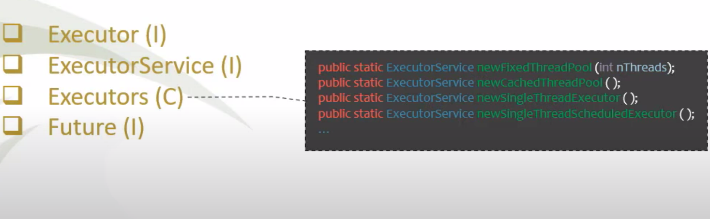

* newFixedThreadPool(int nThreads): this method creates fixed thread pool. It takes int param that specifies no. of threads you want in the pool. At any time, nThreads no of tasks can execute concurrently.
* newCachedThreadPool(): this method continues to create threads as long as there are no tasks pending to execute from the queue. Same thread will be re-used instead of creating new.
* newSingleThreadExecutor(): this method is used to run in the background and it will execute tasks sequentially (one by one) from the queue. No more than one task will be active at any given time. **If an object is shared among multiple concurrently running tasks that read and update it, then those reads and writes need to be synchronized. However, if you use SingleThreadExecutor for all those tasks then need for synchronization is removed as tasks execute sequentially and only one task will be accessing common resource at a time.**
* newSingleThreadScheduledExecutor(): this methods runs scheduled task from queue one by one with a given delay. Executes tasks periodically, e.g. cron job.

Future Interface:

* Whenever you submit callable for execution, the executor returns you an instance of future interface. You can call get() method on this future instance to get value returned by callable task. Call on get() method gets blocked till the task has run to completion and has returned value.
* Future also returns isDone() method to check whether task is completed or not.

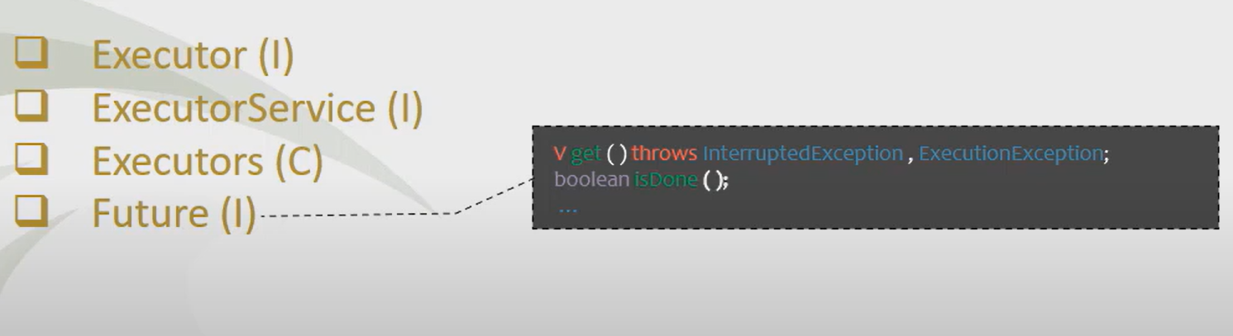

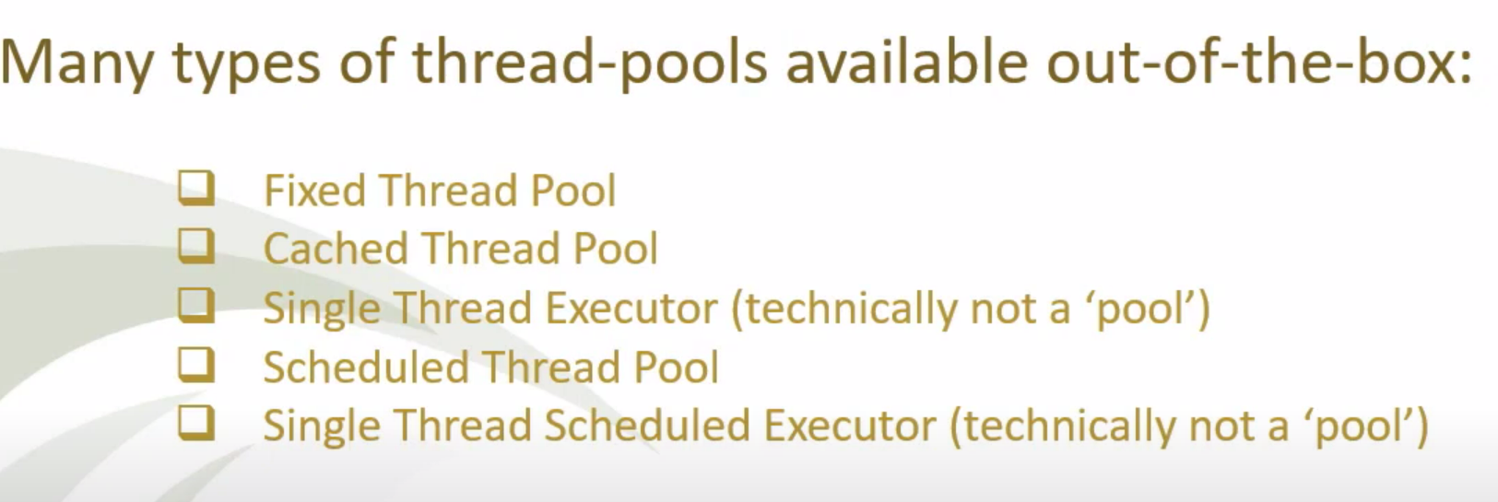

FixedThreadPool Executor:

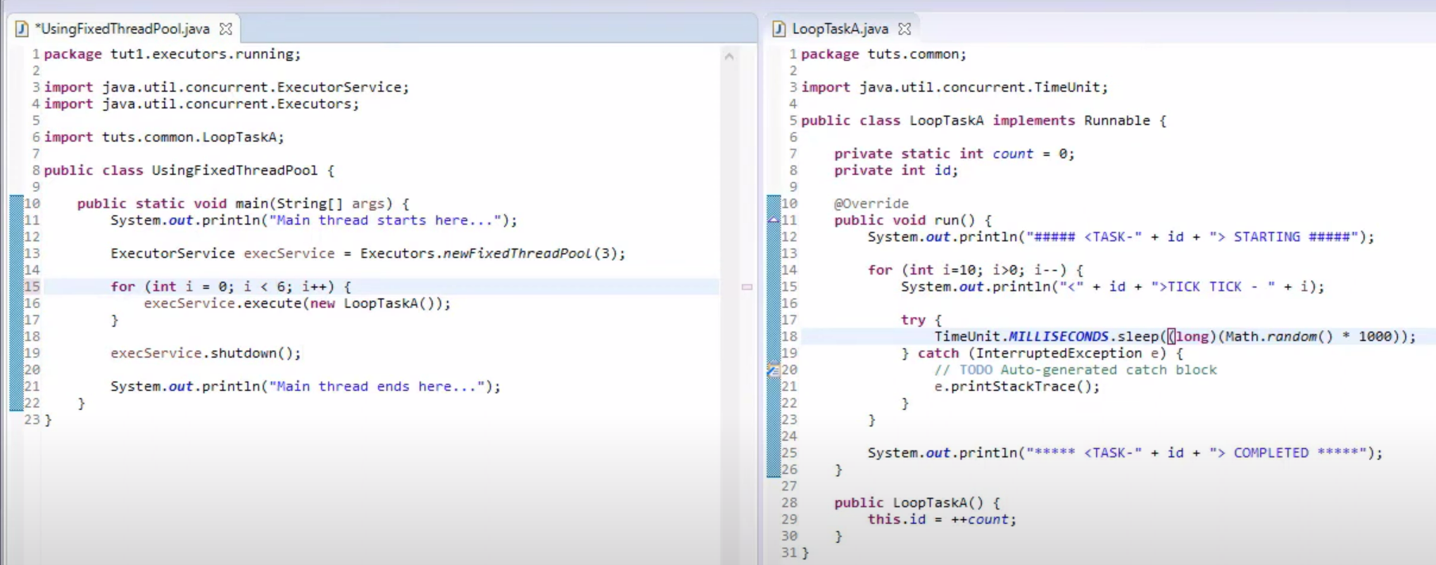

CachedThreadPool Executor:

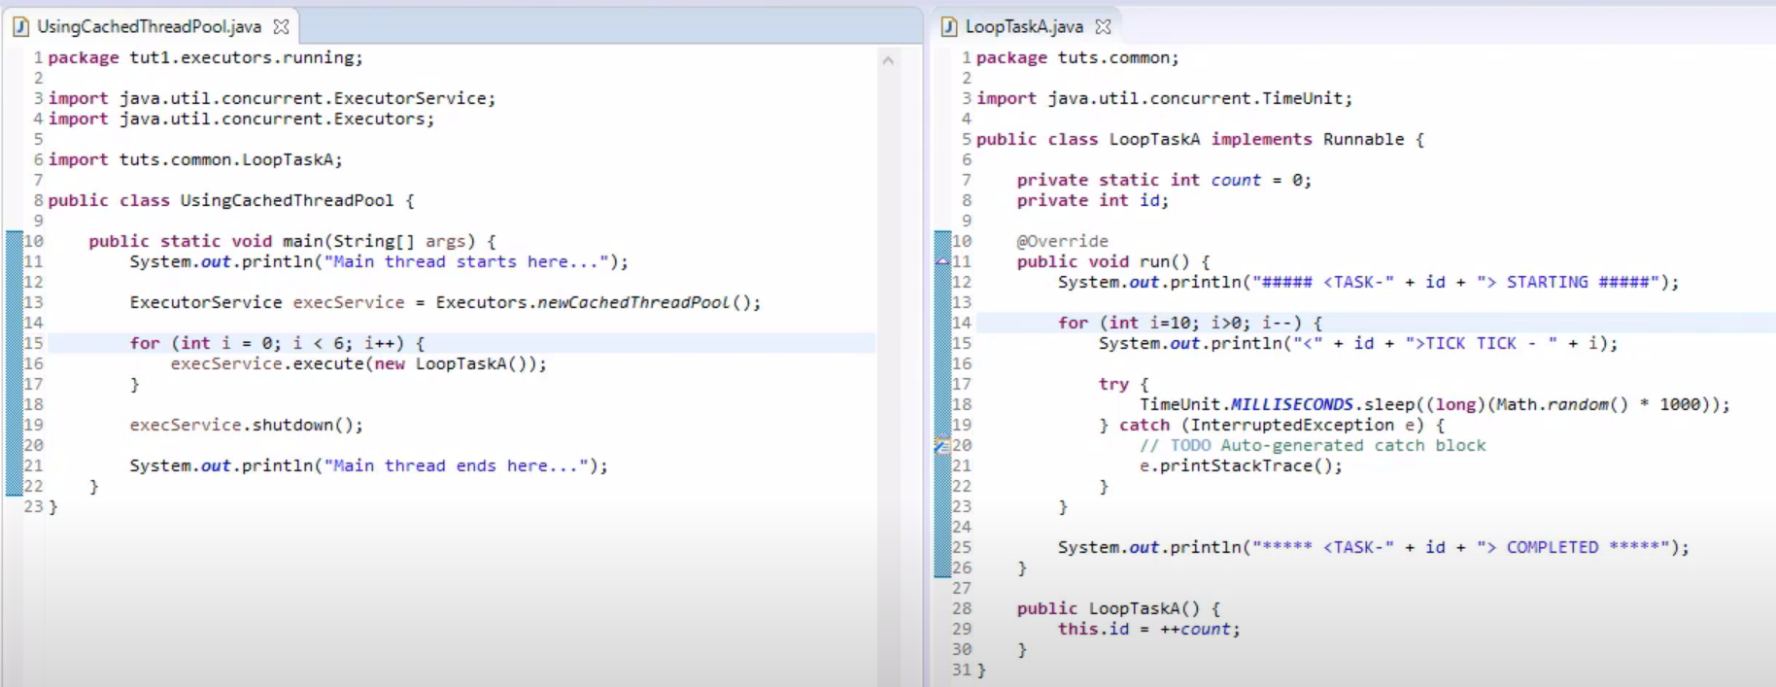

SingleThreadPool Executor:

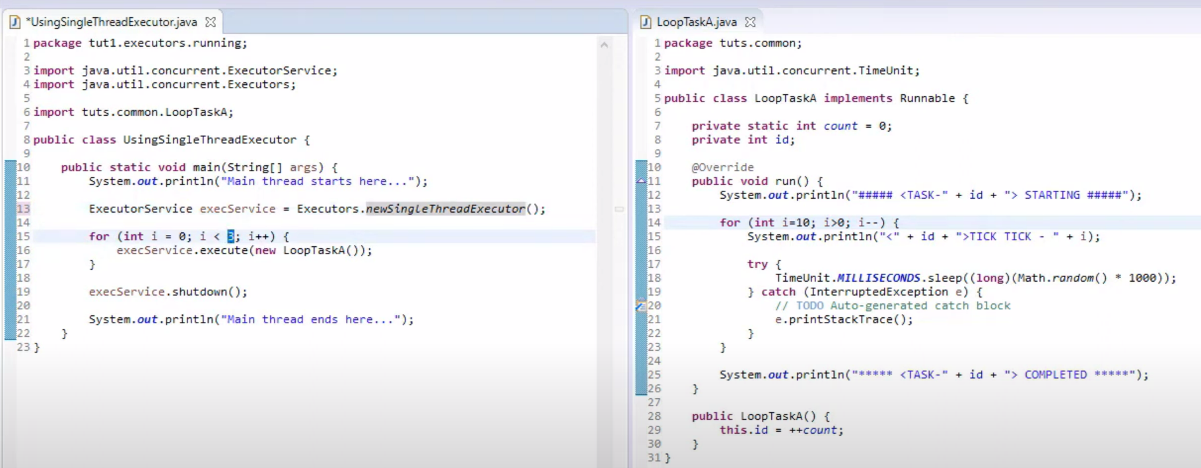

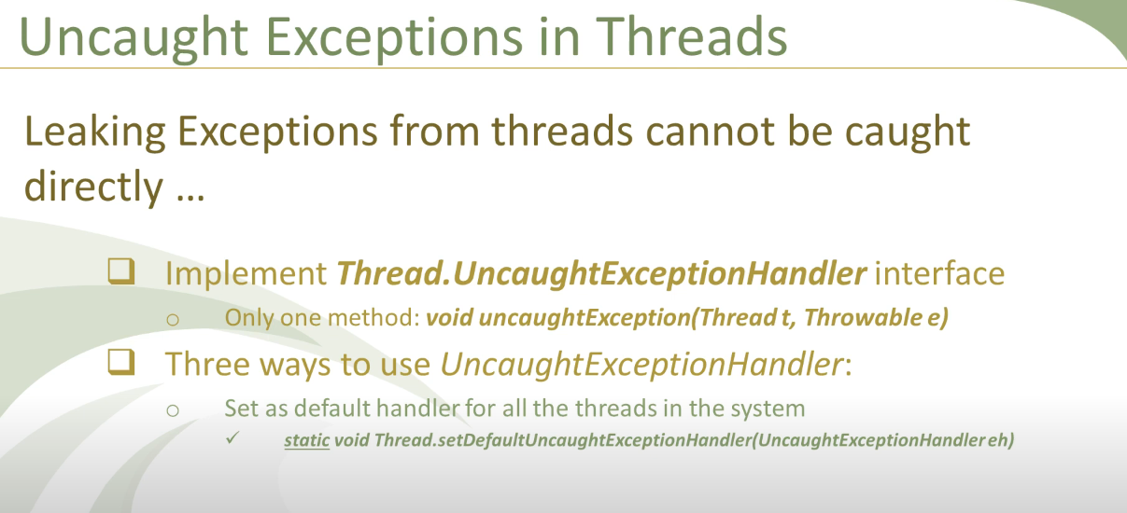

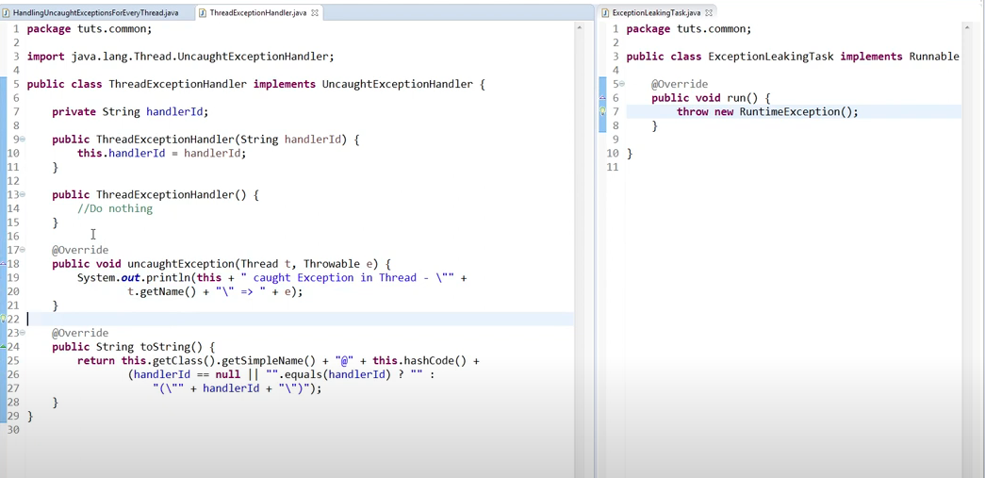

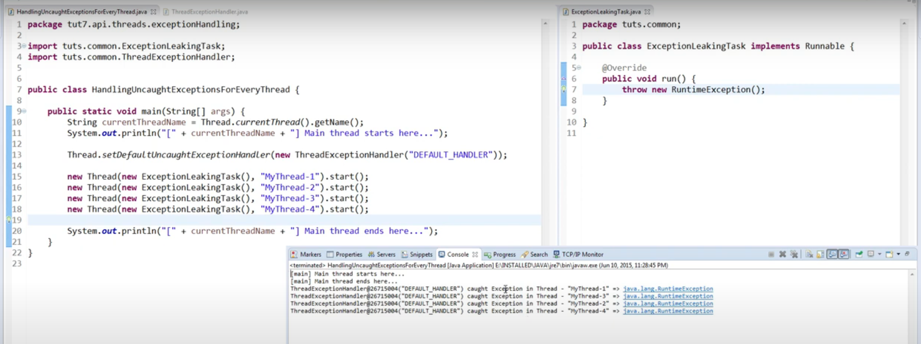

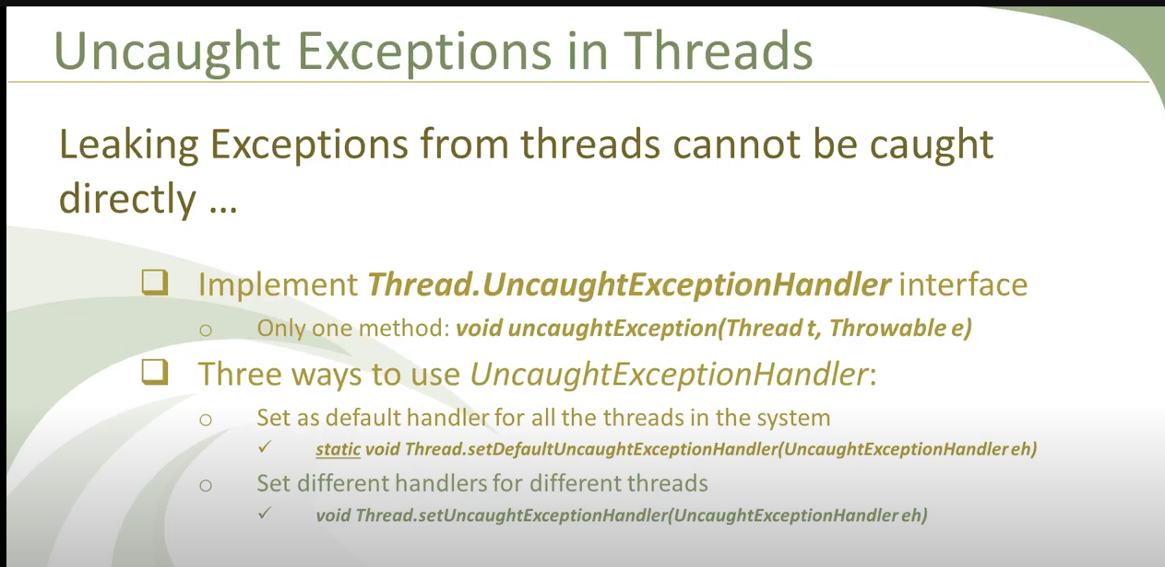

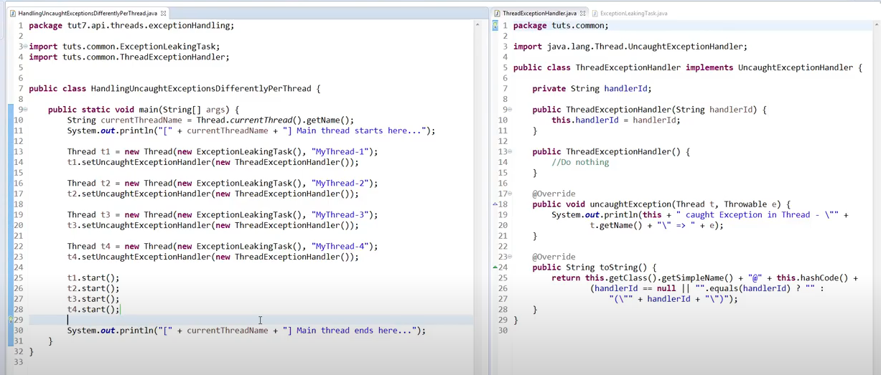

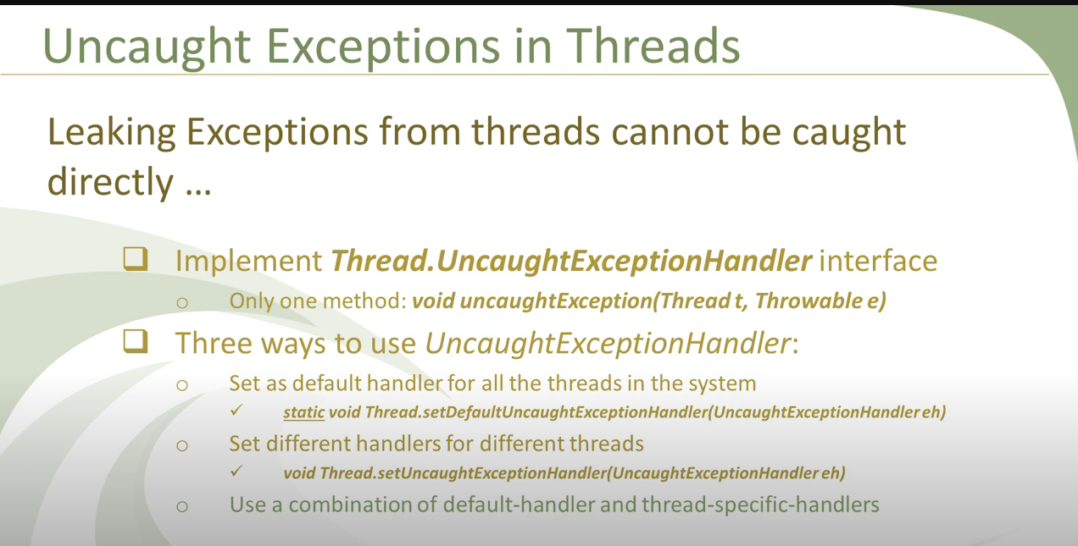

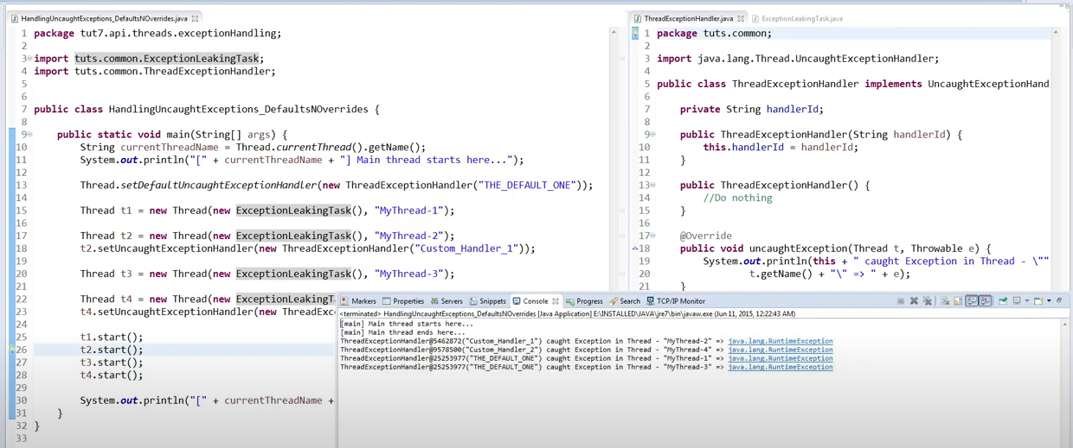

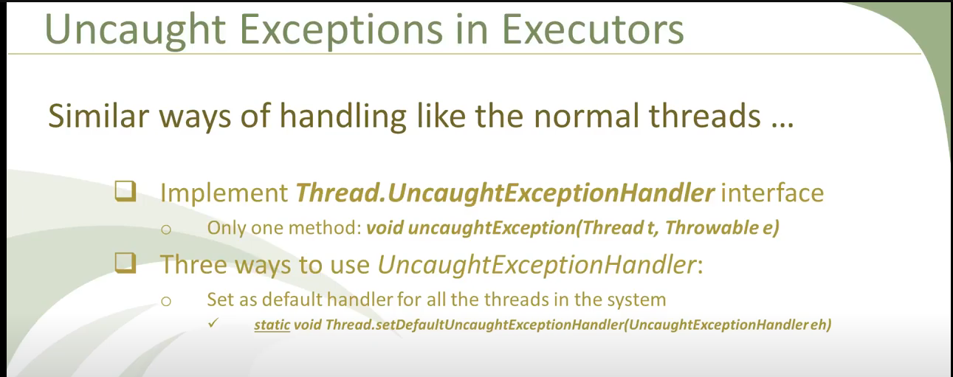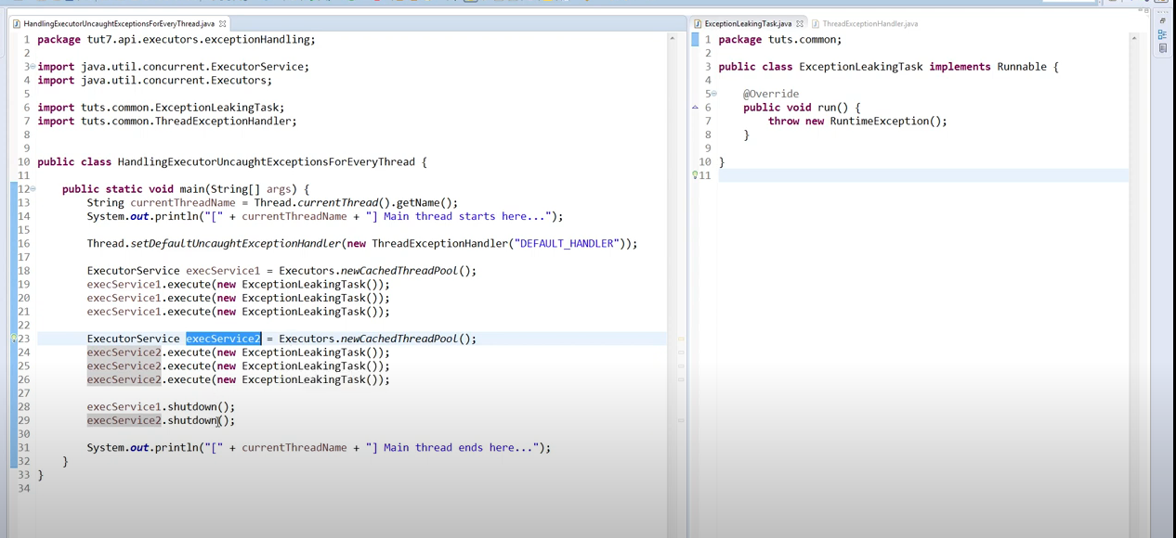

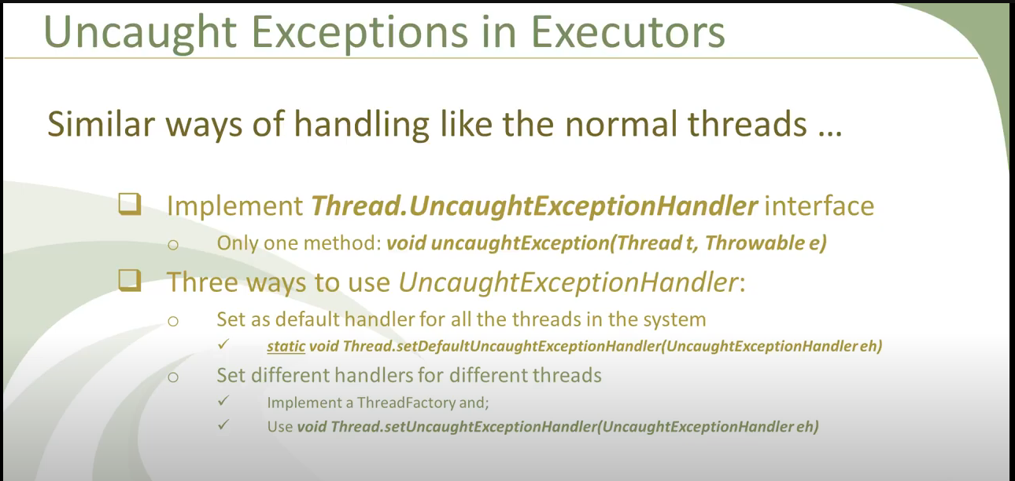

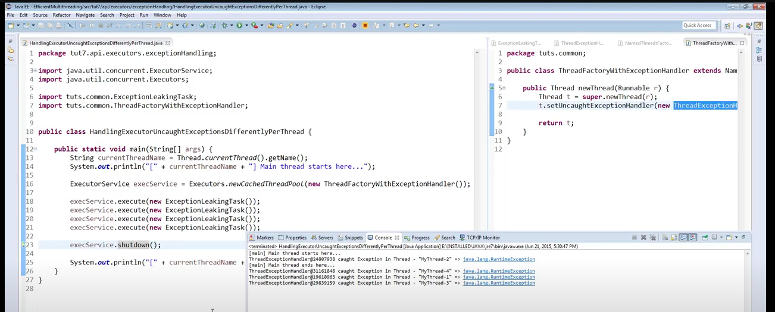

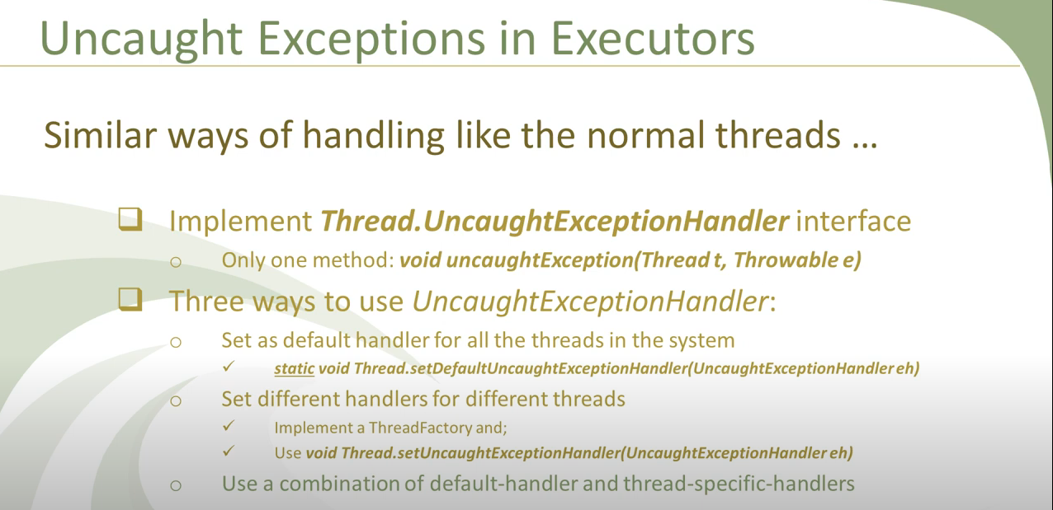

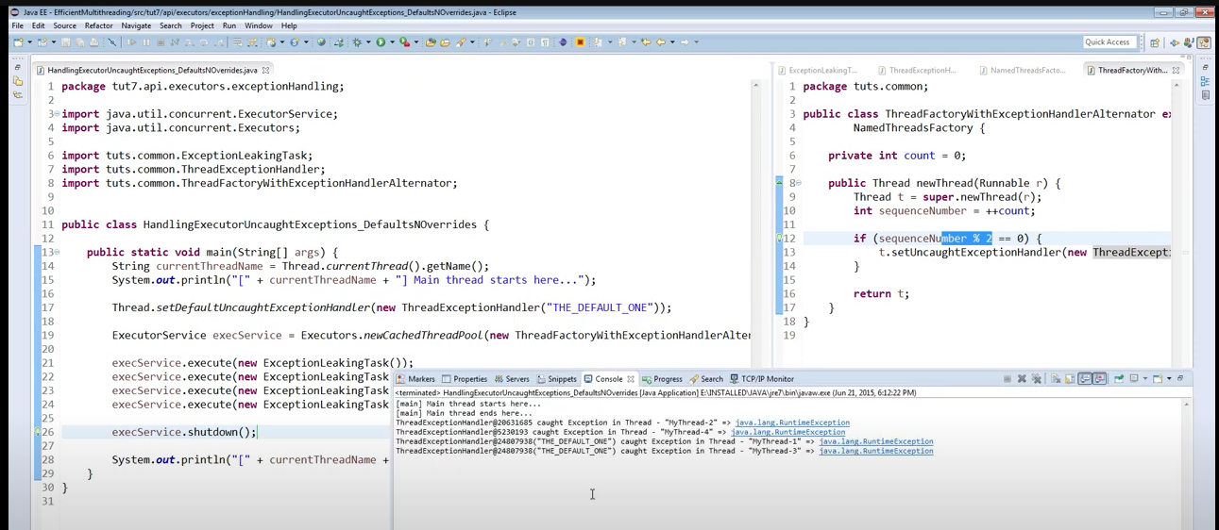

**When would you use the awaitTermination method?**

There are three shutdown methods for an ExecutorService.

* The basic **shutdown** method prompts the tasks to terminate by only allowing for the execution of tasks you have previously submitted.
* The **shutdownNow** method attempts to forcibly stop all actively executing tasks and waiting tasks, which leads to a quick shutdown.
* The **awaitTermination** method prevents shutdown until all tasks have completed execution or the timeout period ends. This is helpful when you do not want to initiate a shutdownNow but want all tasks to execute instead of just the active ones.

**Can you describe different ways for submitting a task to executor framework?**

There are four ways to submit a task to the Executor Framework.

* The most basic method is to use **Executor.execute()**, which only submits a task.
* The three other methods each submit a task or multiple tasks and generate a return.
* **ExectorService.submit()** submits a single task and returns a Future object.
* **ExecutorService.invokeAll()** submits a task collection and returns a list of Future objects.
* **ExecutorService.invokeAny()** submits a task collection and returns the result of one of the tasks that you submitted.

**What are some challenges you might encounter with the Executive Framework?**

* Deadlocks and blocked or starved threads
* Exception handling

**What is the Executive Completion Service class, and what are some of its benefits?**

* The Executive Completion Service class complements an Executor by executing groups of tasks.
* It allows you to submit tasks before their execution and track their status as they execute.
* This is ideal for managing many tasks at once, particularly those you want to execute in a certain order or those you expect to take an extended period of time.